Alerts -
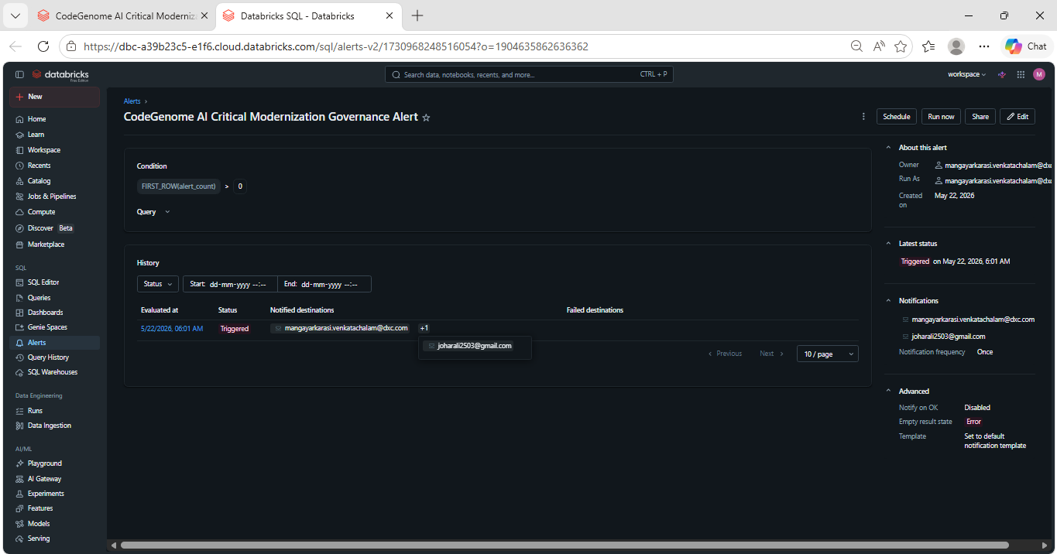
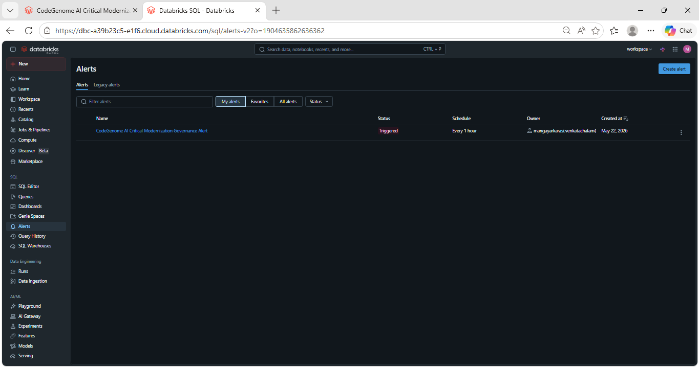
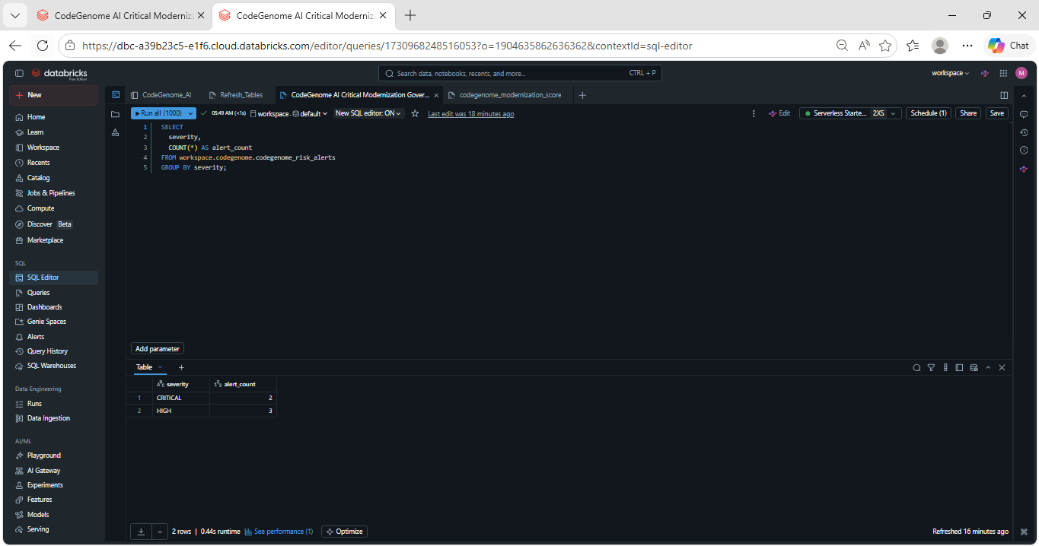
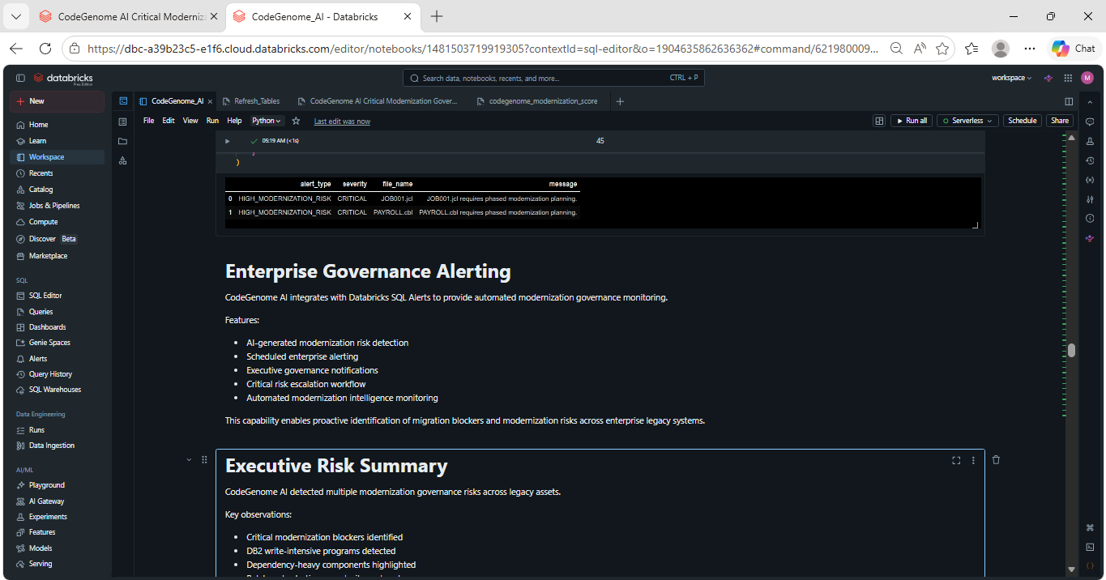
Dashboard Link –
https://dbc-a39b23c5-e1f6.cloud.databricks.com/dashboardsv3/01f1533b04061e12b257cacd5c436d15/published?o=1904635862636362

